CONSTRUCTION OF COMPETENCY MODEL FOR COLLEGE COUNSELORS IN HAINAN PROVINCE, CHINA

Zhao Wei Yu^{1*}, Jiang Yong Zhi²
^{1*}Krirk University; Bangken District, Bangkok, Thailand;10220
²Krirk University; Bangken District, Bangkok, Thailand;10220
*Corresponding Author: Zhao Wei Yu
*Krirk University; Bangken District, Bangkok, Thailand;10220
Email: 547820411@qq.com
Abstract
Counselors are a distinctive profession in China's colleges and universities, functions similar to those of student affairs administrators in other universities around the world, China's Hainan Province is currently building an international free trade port.
The article aims This study aims to explore the competencies of college counselors in Hainan Province, China in this context. Building Competency Models. Providing referable practice model and theoretical foundation for the construction and development of college counselor team in Hainan Province, China.
Methodology Through literature analysis, comparative analysis method, behavioral event interview method, Delphi expert consulting method and other research methods to cohesively summarize the elements of college counselor competency in the context of the construction of Hainan Free Trade Port, and construct a competency model. The constructed model was also validated by statistical analysis of data through questionnaire method.
Results Through the comparative analysis of related literature and empirical investigation, this study constructed a competency model of Chinese college counselors in Hainan Province based on four dimensions and 20 competency elements, namely, "personality traits", "professional qualities", "internationalization ability", and "scientific research ability". The study constructed a competency model for college counselors in Hainan Province, China, structured on four dimensions and 20 competency elements: personality traits, professional quality, internationalization ability, and scientific research ability.
Keywords: colleges and universities in Hainan Province, China, counselors, competency, modeling

- Introduction
Counselor is an important position of student education in Chinese colleges and universities, running through the whole process of college students' education, study and life, with the dual identity of teacher and manager, and is a key part of student education work.China's Hainan Province, a pilot free trade zone with Chinese characteristics, is currently an important area for China to connect with the international community, and has rapidly brought education in China's Hainan Province in line with international standards by introducing internationally renowned universities and educational institutions to the area and bringing in a large number of international talents.In summary, there is an urgent need to improve the competency level of the counselor team in the universities in Hainan Province, China, so constructing a competency model is of great practical significance and theoretical value for the construction and development of the counselor team in the universities in Hainan Province.The theoretical part of this study confirms that there is a lack of appropriate competency modeling tools and related theoretical guidance in current universities in Hainan Province, China.By conducting behavioral event interviews with college counselors in Hainan Province, China, as well as Delphi expert consultation and other research methods, the elements of competency of college counselors in Hainan Province, China, were cohesively summarized.The study learned that among the four dimensions summarized, counselors generally believed that moral character, charisma, work achievement, self-discipline and self-awareness, and psychological stress resistance in the personality trait dimension were the most basic professional competencies that counselors in colleges and universities in Hainan Province, China, should possess at present.The professional quality dimensions of professionalism, crisis management ability, organizational management ability, education and guidance ability, caring for students, knowledge reserve, reporting ability, and comprehension of national policies and guidelines are the job competencies that counselors in colleges and universities in Hainan Province, China, must have at present.International communication ability, communication ability, and knowledge of Hainan Free Trade Port in the internationalization competency dimension are the characteristic competency conditions that must be possessed by college counselors in Hainan Province, China at present.Research ability, learning ability, writing ability and teamwork ability in the dimension of research and learning ability are the necessary competency elements that college counselors in Hainan Province, China, should possess in terms of career development and competency enhancement.
- Literature review
The concept of competence was first formalized by Harvard professor, David McClelland (1973).At that time, it was set up for the selection of diplomats for the United States, and is mainly a deep-rooted personal characteristic that distinguishes those who have excellent performance in a certain job from those who are average, which can be motivation, traits, self-image, knowledge of a certain domain, cognitive or behavioral skills, attitudes and values, and any other individual characteristics that can be measured or counted and that can significantly differentiate between excellent and average performance. Other scholars have also defined competency from a broader perspective, suggesting that competency encompasses occupational, behavioral, and strategic integration dimensions.Firstly, the occupational dimension refers to the skills to deal with specific, day-to-day tasks, the behavioral dimension refers to the skills to deal with non-specific, other personalities, and the strategic-integrative dimension refers to the skills to manage in the context of organizational scenarios.Scholar Spencer (1993) firstly constructed a model about competency "Iceberg Model", which is mainly divided into two parts, the upper part of the iceberg, that is, the part that floats out of the sea, is the explicit traits, the basic competency traits that can be easily observed, which usually contain two dimensions, namely, knowledge and skills. The lower part of the iceberg is the implicit one hidden below the sea level, which means internal and hidden, and it is the distinguishing competency trait, which contains four dimensions: social role, self-image, trait (personality), and motivation. This model is often cited by scholars at home and abroad, and is used in personnel selection and assessment in various industries.Mansfield RS (1996) argues that competency is a collection of individual characteristics such as knowledge literacy, technical skills, motivation, traits, etc. and has some impact and influence on job performance.GreenP.C (1999) further suggests that competence is measurable.WeickK (2001) pointed out the competency dimension of competence, which is the physical and mental application of the knowledge possessed by an individual in facing real-world problems.The distinction between competence and knowledge makes it necessary to contextualize the learning of competence, and the empowerment of individuals requires that their environment be constructed first.Boyatzis (1982) proposes that competence is a personality trait such as motivation, ability, identity, knowledge, etc., that an individual has to excel over other individuals in accomplishing a certain thing or job. The scholar's statement goes further than the previous one by proposing specific measurements that indicate superiority over others.
In scholars' research on the competence of Chinese college counselors, scholars Yang Jiping and Gu Qian (2004) believe that "the competence of college counselors refers to the four structural elements of personality, behavior, ability, and knowledge, which can be measured by 16 indicators, such as the ability to express themselves verbally, the ability to communicate, and the ability to organize".Scholar Xu Jianping (2004) "conducted research on teachers and constructed an assessment model of teacher competency, which includes 11 competency characteristics, namely: responsibility, self-confidence, motivation, self-knowledge, self-management ability, knowledge and skills, creativity, observational ability, communication and coordination ability, thinking ability, and efficiency consciousness".According to scholar Xu Yanhong (2009), "further research on counselors has been conducted to construct a competency model for college counselors, which contains five dimensions: personality qualities, political qualities, counselor's work ability, work quality, and the ability to develop others".Scholar Chen Yansong (2010) studied the "CKR" model and extracted five dimensions of competence, knowledge, self-imagery, motivation, and personality traits to differentiate between high-performing and average-performing counselors through the behavioral event interview method.Scholar Wang Shuzhen (2012) studied "the impact of competency on organizational performance, and constructed a dynamic performance appraisal model based on competency, which contains three dimensions: task dimension, adaptability, and personal relationship".
- Aims
According to the research background and the literature research of related scholars, this study will construct a counselor competency model suitable for the career development of counselors in colleges and universities in Hainan Province, China, by means of empirical investigation. It provides a practical model and theoretical foundation for the development and construction of college counselor teams in Hainan Province, China.
- Materials and Methods
By dividing 30 counselor practitioners in universities in Hainan Province, China, who met the conditions set in advance into a performance excellence group and a performance ordinary group, conducting behavioral event interviews and making audio recordings, and transcribing about 300,000 words of the audio recordings into three levels of coding and classification using the Nvivo 14.0 qualitative analysis software, we cohesively summarized the elements of competence.The elements and dimensions of counselor competency that have been initially summarized were repeatedly validated by expert consultation using the "Delphi" expert consultation method. We also conducted a questionnaire survey with 285 counselors from 21 colleges and universities in Hainan Province, China, and analyzed the data statistically using SPSS27.0 and Amos24.0 software to validate the summarized competency dimensions and elements, and finally constructed a model of competency for counselors in colleges and universities in Hainan Province, China.
- Results
Firstly, the competency dimensions and competency elements of college counselors in Hainan Province, China, which were derived after three levels of coding and classification and three rounds of Delphi expert consultation and validation, were made into a structural diagram, which is shown in Figure 1.
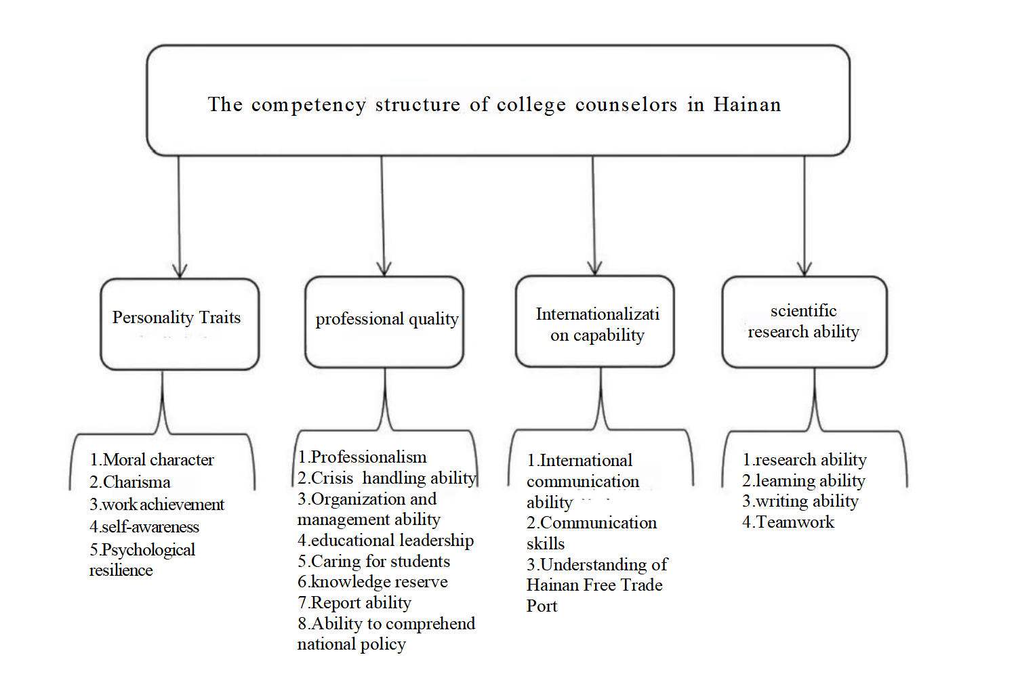
Figure 1 Competency structure of college counselors in Hainan Province, China
Descriptive statistics of interview length and word counts as well as independent samples t-tests were conducted for the audio transcribed text of the two groups of 30 who participated in the behavioral incident interviews as well as correlation analyses for the excellent performance group and the average performance group.
group | item | maximum value | minimum value | average
Excellent performance group | time (minutes) | 95.0 | 73 | 76.9
 | word count | 17360 | 11098 | 13410
performance group | time (minutes) | 88 | 69 | 81.4
 | word count | 14218 | 9689 | 12259
Table 1 Basic descriptive statistics on interview length and word counts

 | Levine's isotropic homogeneity test |  | Mean Equivalent T-Test
 | F | significance | t | degrees of freedom | p | mean difference | standard error | Difference 95% confidence interval upper limit lower limit
Assuming equal variance | .025 | .875 | 1.735 | 28 | .094 | 1152.333 | 664.093 | -207.999 | 2512.665
Not assuming equal variance |  |  | 1.735 | 27.589 | .094 | 1152.333 | 664.093 | -208.911 | 2513.578
Table 2 Independent t-test for transcribed text

 |  | interview duration | Transcript word count
interview duration | Pearson correlation | 1 | .753**
 | p |  | ＜.001
 | n | 30 | 30
Transcript word count | Pearson correlation | .753** | 1
 | p | ＜.001
 | n | 30 | 30
Table 3 Correlation between interview length and word count of transcribed text
From the data in the above table, it can be seen that there is no significant difference in the number of words in the transcribed text between the "excellent performance group" and the "ordinary performance group" (P=0.875＞0.05), which indicates that there is no problem of poor stability in the number of words in the transcribed text of the interviews with counselors in colleges and universities in Hainan Province, China. This indicates that there is no problem of poor stability in the word count of the transcribed texts of the interviews of college counselors' competence in Hainan Province, China.
This study continues the preliminary formation of China's Hainan Province college counselor competency dimensions and elements of expert weighting analysis, in order to avoid personal subjective awareness of the impact of the scoring standards, specifically for the nine experts to develop a "judgment scale definition table", the experts use a four-point system to compare and analyze the relative importance of the two dimensions, that is, the rows of factors and columns of factors are compared with each other.
Benchmark（Score） | Definition
0 | Dimension X is very unimportant to dimension Y
1 | Dimension X is less important than dimension Y
2 | Dimension X is as important as dimension Y
3 | Dimension X is more important than dimension Y
4 | Dimension X is very important relative to dimension Y
Table 4 Judgment Scale Definition Table
This study also developed a "dimension weighting table" for the one-dimensional level of the competency model, as shown in Table 5, and by analogy, we can continue to design a "factor weighting table" for the two-dimensional level.
Y  X | Personality Traits | professional quality | Internationalization capability | Scientific research and learning ability | score  （sum per row）
Personality Traits | empty value
professional quality |  | empty value
Internationalization capability |  |  | empty value
Scientific research and learning ability |  |  |  | empty value
Table 5 One-dimensional factor weights judgment table
According to the above weight judgment table, first calculate the average score of each dimension in the table, use the summed score of each row divided by the difference of the number of factors minus one as well as the sum of average scores, and then divide the average score of each dimension by the sum of the average scores of each dimension, and the result is the weight of each dimension, and the results are detailed in Table 6.
Dimension | The average score | Weights | to sort
Personality Traits | 20.67 | 0.34 | 1
professional quality | 15.33 | 0.32 | 3
Internationalization capability | 17.67 | 0.31 | 4
Scientific research and learning ability | 20 | 0.33 | 2
Table 6 Weighting of dimensions
Based on the above research and resultant data, a competency model for counselors in Hainan universities can be initially constructed. The model covers four competency dimensions of personality traits, professional quality, internationalization ability, and research and learning ability, as well as 20 competency elements.
After behavioral event interviews and Delphi expert consultation as well as expert weighting analysis, based on the preliminary structure of the competency model for college counselors in China's Hainan Province, the Competency Verification Questionnaire for College Counselors in China's Hainan Province was released to 285 counselors from 21 universities in China's Hainan Province, and the questionnaires were subjected to statistical data analysis to further validate the structure and complete the final construction of the model.
Firstly, the 27 items designed in the questionnaire were item analyzed, and after several rounds of analysis, the 2 items in the original questionnaire with non-significant results of differentiation were deleted, and the remaining 25 to questionnaire items were all significant (P < 0.05), indicating that the remaining 25 items in this questionnaire have relatively good differentiation, and do not need to be deleted.
The second step was to conduct an exploratory factor analysis of the remaining 25 questionnaire items.
KMO | 0.922
Bartlett | Approximate chi-square | 4099.674
 | degrees of freedom | 300
 | p | 0.000
Table 7 KMO and Bartlett's test of sphericity
Based on the results of the above tests, it can be seen that the KMO value is 0.922, which is greater than 0.9, indicating that the question items of this questionnaire measure the best, and the significance of the Bartlett's test of sphericity is 0 (P=0.000), which indicates that it reaches a significant level, proving that there are common factors between the matrices, and therefore it is suitable to continue with the factor analysis.
This exploratory factor analysis adopts "principal component analysis" to extract the factors, while this study will first set the limitation to extract the factors according to the four dimensions in the competency model of college counselors in Hainan Province of China that has been preliminarily constructed, and set the value to 4, and then adjust the information loadings of each factor according to the method of "Maximum Variance Orthogonal Rotation". " method, the information loading of each factor is adjusted. In this study, five rounds of factor analysis were repeated, and 20 questionnaires were finally retained. The final cumulative variance explained was 70.41%, which is an acceptable level.
This validated factor analysis satisfies several basic conditions, with a sample size of 285 and a final question item of 20, which is greater than 10:1, indicating that the sample size for this analysis is excellent, and the specific results of the analysis, which are detailed in the structural equation diagram in Fig. 2, the overall fit coefficients table in Table 8 (structural validity), and the factor loadings table in Table 9 (convergent validity),Table 10 (discriminant validity).

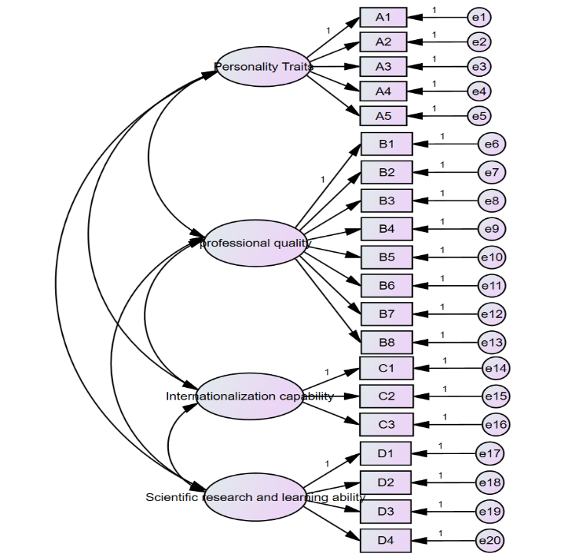
Figure 2 Structural equation diagram
x²/df | RMSEA | GFI | AGFI | CFI | IFI | TLI
1.558 | 0.005 | 0.932 | 0.985 | 1.000 | 1.000 | 1.000
Table 8 Table of overall fit coefficients (structural validity)
According to the data in Table 8, x²/df is 1.558, with a value less than 3, RMSEA value is 0.005, less than 0.05, GFI value is 0.932, greater than 0.9, AGFI value is 0.985, greater than 0.9, CFI value is 1.000, greater than 0.9, IFI value is 1.000, greater than 0.9, TLI value is 1.000, greater than 0.9, proving that the model fit validity is good.
path | Estimate | AVE | CR
A1<---F1 | 0.927 | 0.7365 | 0.933
A2<---F1 | 0.767
A3<---F1 | 0.845
A4<---F1 | 0.843
A5<---F1 | 0.900
B1<---F2 | 0.920 | 0.6158 | 0.9273
B2<---F2 | 0.735
B3<---F2 | 0.794
B4<---F2 | 0.785
B5<---F2 | 0.799
B6<---F2 | 0.733
B7<---F2 | 0.785
B8<---F2 | 0.708
C1<---F3 | 0.731 | 0.6179 | 0.8273
C2<---F3 | 0.706
C3<---F3 | 0.906
D1<---F4 | 0.829 | 0.7225 | 0.912
D2<---F4 | 0.755
D3<---F4 | 0.895
D4<---F4 | 0.912
Table 9 Factor loadings table (convergent validity)
According to the data in Table 9, the factor loadings of each latent variable (dimension) of F1, F2, F3, and F4 corresponding to each question item are all greater than 0.7, indicating that each latent variable (dimension) corresponding to the question item to which it belongs is highly representative. According to the data, the average variance of variance AVE of each latent variable is greater than 0.6 (standard AVE > 0.5), and the combination reliability CR is greater than 0.8 (standard CR greater than 0.7), which indicates that the reliability and validity are relatively good.
 | F1 | F2 | F3 | F4
F1 | 0.74
F2 | 0.78 | 0.62
F3 | 0.79 | 0.65 | 0.62
F4 | 0.69 | 0.72 | 0.73 | 0.72
AVE | 0.86 | 0.78 | 0.79 | 0.85
Table 10 differentiation of validity
According to the results of the data in Table 10, it can be seen that the values of AVE square root are greater than the correlation coefficients of each factor with other factors, which indicates that there is a certain degree of correlation between the latent variables and a certain degree of differentiation between each other, and the discriminant validity of this scale is good.
Finally, the questionnaire is tested for reliability, and the internal consistency of the scale is generally tested by the value of the Cronbach's Alpha coefficient, which requires that the minimum Cronbach's Alpha coefficient for each dimension should be greater than 0.5, and the overall scale's Cronbach's Alpha coefficient, should be greater than 0.7. Below in the present study, the results of the reliability test are detailed in Table 11.
Dimension | Cronbach’s Alpha | Number of items
Personality Traits | 0.931 | 5
professional quality | 0.733 | 8
Internationalization capability | 0.510 | 3
Scientific research and learning ability | 0.564 | 4
Table 11 Cronbach's alpha coefficient reliability for each dimension
According to the results of Cronbach's Alpha coefficient reliability analysis of each dimension, the Cronbach's Alpha coefficient of each dimension is greater than 0.5, with good reliability, and in the subsequent test of the overall reliability of the questionnaire, the results of Cronbach's Alpha coefficient reliability of the overall scale, the overall scale Cronbach's Alpha coefficient is 0.911, which is greater than 0.7 indicating that the overall scale has high overall consistency, strong reliability, and good reliability, and the Cronbach's Alpha coefficient after deletion of each item in the data is less than or equal to 0.911, which proves that there is no need for deletion of the items.
Finally, this study will be carried out for the scale folded half reliability analysis, the need to divide the questionnaire as a whole into two parts, the two parts of the reliability analysis, according to the analysis of the previous results, after the deletion of the corresponding items of the questionnaire after the final questionnaire for 20 items, divided into two parts of the questionnaire were 10 items to do folded half reliability analysis. See Table 12 for details.
Cronbach’s Alpha | Part I | worth | 0.884
 |  | number of questions | 10
 | Part II | worth | 0.767
 |  | number of questions | 10
 | Total items | 20
Correlation between morphologies | 0.837
Spearman-Brown factor | equal length | 0.911
 | unequal | 0.911
Gettleman's halving factor | 0.895
Table 12 Discounted reliability analysis
According to the results of the folded half reliability analysis in Table 12, the reliability of the first part of the questionnaire was 0.884 and the reliability of the second part of the questionnaire was 0.767, and the Kronbach Alpha coefficients of the two parts of the questionnaire were greater than 0.7, which indicated that the reliability was good. The Spearman-Brown coefficients for the overall scale were all 0.911, which is greater than 0.9, indicating that the consistency of this scale is high, the scale fold-half reliability is very reliable, and the test results are acceptable.
- Discussion
Based on the preliminary construction of the competency model for college counselors in Hainan Province, and the results of the "Competency Verification Questionnaire for College Counselors in Hainan Province, China" which was developed based on the preliminary construction of the model, after item analysis of the scale, KMO value and bartlett sphericity test, exploratory factor analysis, validation factor analysis, and reliability test, it is concluded that the competency model for college counselors in Hainan Province consists of 4 factors (dimensions) and 20 elements. After item analysis, KMO value and bartlett sphericity test, exploratory factor analysis, validity test, and reliability test, it is concluded that the competency model of counselors in Hainan colleges and universities consists of 4 factors (dimensions) and 20 elements, which are "personality traits", "professional quality", "internationalization ability", and "internationalization ability". internationalization ability" and "scientific research ability". The final interpretation of the formalized competency model for college counselors in Hainan Province, China is presented below.
- Personality traits, this dimension refers to one of the competency dimensions required for college counselors in the context of the construction of Hainan Free Trade Port, which covers the counselors in this context, the need to have good moral character, and how to form a certain charisma through their own behavior in their work, so that the students so as to admire themselves, play a better role in the work of charisma, but also have a certain sense of accomplishment, only to produce a certain sense of accomplishment of their work, in order to take their work more seriously. A certain sense of accomplishment, only to produce a certain sense of accomplishment of their work, in order to treat the work of counselors more seriously, but also have self-discipline and self-awareness, this point is crucial, counselor's work, self-discipline and self-awareness is to promote efficiency, reduce the possibility of error necessary factors, at the same time, due to the complexity of the work of the college counselor, encountered a wide variety of things, this At the same time, due to the complexity of the work of college counselors, they encounter a variety of things, which also requires that counselors must have a strong psychological resilience, able to accept the pressure brought by the work of their own, and do a good job of psychological adjustment, and at any time to face the things in a better working condition.
- Professional quality, this dimension mainly refers to the construction of Hainan Free Trade Port in the context of college counselors should have some basic professional qualities, including a certain degree of professionalism, which requires counselors must have a strong sense of enterprise, sense of responsibility, to cut the love of counseling work, and at the same time, to their own occupation to produce identity, have a big-picture concept, to do everything to be able to stand in the higher point of view to consider the problem! At the same time, because each counselor has to take 200 students, which also requires counselors need to be clean and self-disciplined, adhere to the bottom line, and also have a strong executive force and high efficiency in the work.As a counselor also has a strong ability to deal with crisis events, in the daily student management process, there are often many unexpected unexpected crisis events, counselors should have the ability to deal with unexpected crisis events at any time to protect student safety, safeguard the rights and interests of students, and become a good counselor worthy of students' trust.As a college counselor should also have strong organizational and management skills, according to the Chinese counselor 1:200 with the student ratio to calculate, each counselor may need to take 3-6 classes, which also need to be able to do the day-to-day work of organizing the management of the class, with strong organizational skills, can effectively improve the cohesion of the class students. Educational guidance ability is also extremely important, counselor work is throughout the whole process of education and teaching of college students, therefore, from the preventive education of new students, academic guidance, psychological guidance during the school period, employment guidance for graduates, etc., are the basic work of the counselor to do, which also requires that the counselor should have a strong educational guidance ability.As a college counselor, caring for students is a basic element of competence, students from all over the world in China, there are also groups of foreign students from abroad, as a counselor to grasp the basic information of the students in a timely manner, according to the family situation of different students, to make targeted work, care for the students in their lives, care for the students in their studies, and keep the last door for students to enter the community. As a counselor, with a certain knowledge reserve is necessary, with the development of the network era, more and more knowledge through a variety of channels into the university campus, the accumulation of knowledge of students is increasing, which also puts forward more challenges to the new era of college counselors, as the saying goes, to give students a bowl of water, the first thing they need to have a bucket of water, the meaning of this sentence is to say that, only more than the students have a wider This means that only by having a broader knowledge base than students and understanding more aspects of knowledge can we not be eliminated by the times and keep pace with the times and become a qualified counselor. In the dimension of professional quality, the ability to report work is also mentioned in particular, which is also one of the necessary elements that counselors should have at present.
- Internationalization ability, internationalization ability can be said to be a new requirement for college counselors in the context of the construction of Hainan Free Trade Port, which is also different from other regions of China's colleges and universities on the basic requirements for the competence of counselors, due to the special nature of the development of the construction of the Hainan Free Trade Port and the necessity of Hainan's regional college counselors are required to have a certain degree of international exchange capabilities, with the entry of various foreign schools, new educational concepts, new educational methods will also continue to come in, the local college counselors should have the ability of international exchange to not be eliminated by the times. Residence, new educational concepts, new educational methods will continue to influx, Hainan local college counselors should have the ability of foreign international exchanges in order not to be eliminated by the times, while the ability to communicate is also extremely important as a counselor to learn how to communicate with foreign master teachers, foreign students, and learn to communicate with the way it is also the inevitable elements of the internationalization dimension of the Hainan region college counselors, of course, internationalization, first of all, as the Hainan Free Trade Port construction development special and necessity. Internationalization, first of all, as a college counselor in Hainan Free Trade Port area, the first to learn to understand is the knowledge of Hainan Free Trade Port, as well as the understanding of relevant policies and regulations, at the same time, to deeply understand the development requirements of Hainan Free Trade Port on the field of education, in order to better close to the reality of the development of the Free Trade Port to be integrated into the work of the counselor.
- scientific research and learning ability, is currently the vast majority of China's counselors ability to weak, the vast majority of regional counselors more focus on the work into the actual work, because of the daily chores, it is rare to do scientific research, which is also a lot of counselors poor theoretical foundation, one of the reasons for the weakness of the research ability, so in order to meet the international standards, as the development of the Hainan Free Trade Port is an important part of the improvement of the college counselor Scientific research ability is also imminent, only more reading of relevant literature, looking for research ideas, recognize the current urgent need to improve their own actual situation, in order to adapt to the development of the current Hainan Free Trade Port, at the same time, the ability to learn and comprehend is also crucial, China has a saying called learning is never-ending, the learning of knowledge has no end, only to constantly learn new knowledge in order to better adapt to the development of the times.
- Conclusions
After a variety of ways of research and discussion, we finally constructed a competency model for college counselors in Hainan Province, China, expecting that it can provide a practical model and theoretical guidance for the development and construction of college counselor teams in Hainan Province, China.
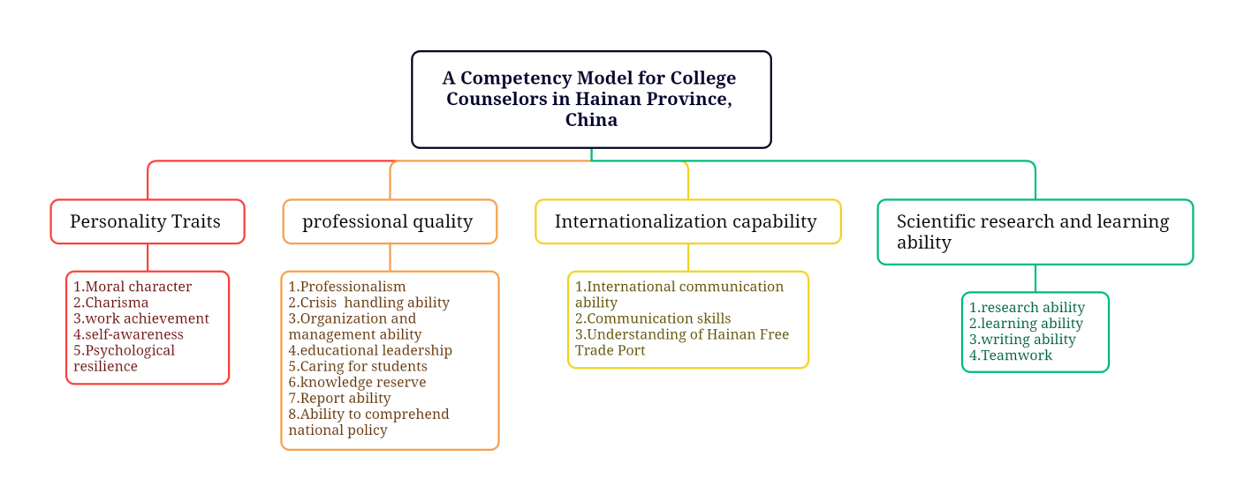
Figure 3 A Competency Model for College Counselors in Hainan Province, China
References
- Wang, S. Z., & Zhang, Q. L. (2012). Research on task performance-relationship performance-adaptive performance management system--based on the perspective of competency model. China Human Resource Development, (8), 5. CNKI:SUN:ZRZK.0.2012-08-013
- Chen, Yansong (2010). Competency model construction of college counselors:An empirical study. Research on Higher Education, (4), 84-89. cnki:sun:high.0.2010-04-018
- Gu, Qian (2004). The development and preliminary application of university counselor competency questionnaire (B841). [Master's thesis, Shanxi University]. China Knowledge.
- Xu, J. P. (2004). Research on teacher competency modeling and assessment (CNKI:CDMD:1.2006.130467). [Doctoral dissertation, Beijing Normal University]. China Knowledge.
- Xu, Yanhong (2009). Research on the competency model of college counselors. [Doctoral dissertation, Capital University of Economics and Business].CNKI:CDMD:2.2009.203973
- David McClellandDC（1973）.Testing for competencer atherthan for intelligence.AmPsychol, 28(1),1-14./doi.org/10.1037/h0034092
- Richard E,Boyatzis(1982).The Competent Manager:A Model for Effective Performance.NewYork:John.Wiley.and.Sons.DOI: 10.4236/jss.2014.22006
- Spencer L M, Spencer S M（2008）. Competence at Work: Models for Superior Performance Education .Higher Education, 2004(48),253- 268.
- Green, P. C. (1999). Building robust competencies: linking human resource systems to organizational strategies. linking human resource systems to organizational strategies.
- Mansfield R.S(1996),Building Competency Models:Approaches for HR Professionals.Human Resource Management．35(1),7-18.
- Weick K(2001).Making sense of the organization.Blackwell Publishing Ltd.DOI: 10.4236/iim.2010.28054

